LAB 7
Task 1:
include irvine32.inc

.data
num dword ?
msg1 byte "Enter number: ",0
msg2 byte "Sum is: ",0

.code
main proc
mov ecx,10
mov ebx,0
L1:
mov edx,offset msg1
call writeString
call readInt
mov num,eax
cmp eax,0
JZ skip
add ebx,num
loop L1

skip:
mov eax,ebx
mov edx,offset msg2
call writeString
call writeDec

exit
main endp
end main
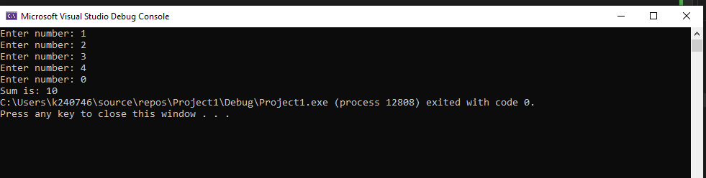

Task 2:
include irvine32.inc

.data
marks dword ?
msg1 byte "Enter marks: ",0
msg2 byte "Grade is A",0
msg3 byte "Grade is B",0
msg4 byte "Grade is C",0
msg5 byte "Grade is D",0
msg6 byte "Grade is F",0

.code
main proc
mov edx,offset msg1
call writeString
call readInt
mov marks,eax
cmp eax,90
JAE A
cmp eax,70
JAE B
cmp eax,60
JAE C_
cmp eax,50
JAE D
JMP E

A:
mov edx,offset msg2
call writeString
exit

B:
mov edx,offset msg3
call writeString
exit

C_:
mov edx,offset msg4
call writeString
exit

D:
mov edx,offset msg5
call writeString
exit

E:
mov edx,offset msg6
call writeString
exit
main endp
end main

